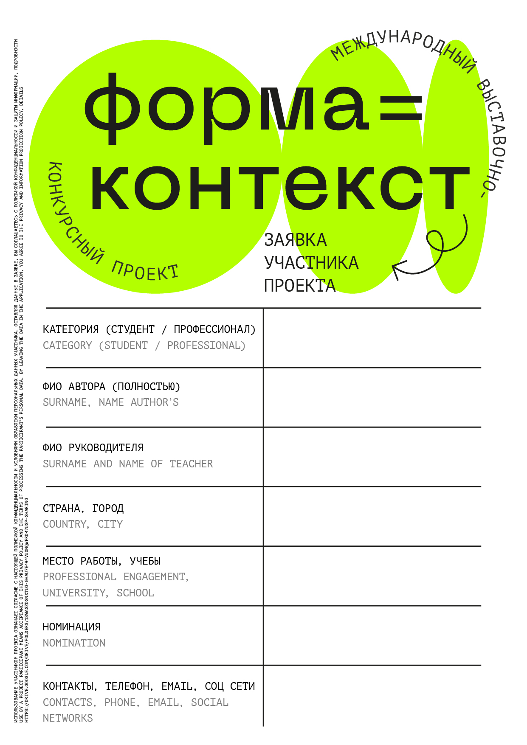

Poster

e-mail, 8-888-888-88-88

DONSTU

Russia, Rostov-on-Don

Petrov Petr Petrovich

Ivanov Ivan Ivanovich

student